SIMATS ENGINEERING
ASSESSMENT TOOL II — VISUALIZATION EVALUATION EXERCISE
Course: Data Handling and Visualization | Code: DSA0603 | CO: CO4
Duration: 60 min | Total Marks: 50 | Reg No:  Name:

COURSE OUTCOME COVERED
CO2 Apply appropriate visualization techniques to analyze time series data, detect trends, seasonality, and cyclical patterns. (BL3)
Activity Tool : Visualization Evaluation Exercise
Weightage: 20%
Code of Conduct:
I ______Neeleash H_______(192524093)_________ (Name / Reg No) certify that this submission is my original work and that I have adhered to the guidelines specified for this assessment. I understand that any violation of academic integrity rules will result in disciplinary action.
Signature of the student:
Criteria | Evaluation of Visualization Quality  25% | Critical  Analysis  25% | Application of Visualization Principles  20% | Organization 15% | Accuracy  10% | Clarity  5% | Total
Q1
Q2
Q3
Q4
Q5

Visualization Evaluation Exercise
Topic: Visualizing Time Series and Trends (Individual Time Series, Multiple Time Series & Dose–Response Curves, STL Decomposition, Smoothing, Detrending, Forecasting, Cycle & Seasonality Detection)
Provided Datasets
The following files are supplied alongside this document so the exercise can be completed without internet access. All are real, publicly documented datasets:
● AirPassengers.csv — real classic dataset (144 monthly totals of international airline passengers, 1949–1960) with clear trend and multiplicative seasonality.
● co2_mauna_loa.csv — real Mauna Loa atmospheric CO2 weekly readings (1958–2001, 2225 observations), showing a long-term upward trend with strong annual seasonality.
● Nile.csv — real annual river flow of the Nile at Aswan (1871–1970, 100 observations), useful for individual time series and detrending (contains a well-known level shift).
● sunspots.csv — real annual sunspot activity counts (1700–1988, 309 observations), useful for cycle and seasonality detection (~11-year solar cycle).
● EuStockMarkets.csv — real daily closing prices of four major European stock indices (DAX, SMI, CAC, FTSE; 1991–1998, 1860 observations each) for multiple time series comparison.
● ryegrass_doseresponse.csv — real dose–response data (root length of ryegrass vs. herbicide concentration, 24 observations) from the drc package in R.
Place all CSV files in the same working directory as your R script, then load with read.csv("filename.csv").
Question 1: Individual Time Series & Moving-Average Smoothing
Dataset provided: Nile.csv
Using the Nile dataset, convert the value column into an R ts object (start = 1871, frequency = 1) and plot the raw annual flow as a line chart. Overlay a smoothed version of the series using a moving average (e.g., a 5-year moving average via stats::filter() or zoo::rollmean()). Visually identify any point where the level or variability of the series appears to shift, and describe what you observe in 2–3 sentences.
Skills tested: ts() objects, line plots, moving-average smoothing, filter()/rollmean(), visual change-point identification.
Question 2: Multiple Time Series Comparison & Dose–Response Curve This question has two parts.
Part a — Multiple Time Series
Dataset provided: EuStockMarkets.csv
Plot all four stock indices (DAX, SMI, CAC, FTSE) on the same time axis using ggplot2 (reshape to long format with tidyr::pivot_longer() first). Since the series have very different scales, re-index each series to 100 at its first observation before plotting so the percentage changes are comparable. Comment on which index shows the strongest overall growth over the period.
Part b — Dose–Response Curve
Dataset provided: ryegrass_doseresponse.csv
Plot root_length against concentration as a scatterplot, then fit and overlay a smooth dose–response curve (e.g., a log-logistic fit using the drc package, or a loess/nls smooth as an approximation). Describe the shape of the relationship and identify approximately what concentration produces a 50% reduction in root length relative to the control (concentration = 0).
Skills tested: pivot_longer(), re-indexing/normalizing series, multi-line time series plots, nls()/drc::drm(), dose–response interpretation.
Question 3: Seasonal Decomposition of Time Series (STL)
Dataset provided: AirPassengers.csv
Convert the passengers column into a ts object (start = c(1949,1), frequency = 12). Apply STL decomposition using stl() (set s.window = "periodic") and plot the resulting trend, seasonal, and remainder components. Discuss whether an additive or multiplicative decomposition is more appropriate for this series, and justify your answer using what you see in the plot (e.g., whether seasonal amplitude grows with the trend).
Skills tested: ts() with frequency, stl(), additive vs. multiplicative decomposition, component interpretation.
Question 4: Detrending and Residual Analysis
Dataset provided: co2_mauna_loa.csv
Using the CO2 dataset, fit a linear trend (co2 ~ time) and subtract the fitted values from the observed series to obtain a detrended series. Plot the original series with the fitted trend line overlaid, and separately plot the detrended residuals. Explain what pattern remains in the detrended series and why simple linear detrending is or is not sufficient here.
Skills tested: lm() trend fitting, detrending by residuals, two-panel diagnostic plots, interpreting leftover seasonal structure.
Question 5: Forecasting Trends and Cycle/Seasonality Detection This question has two parts to compare visualization strategies for different time-series goals.
Part a — Forecasting Trends
Dataset provided: AirPassengers.csv
Using the forecast package (or fable), fit an ETS or auto.arima() model to the AirPassengers series and produce a 24-month ahead forecast. Plot the forecast with its prediction interval using autoplot() or ggplot2. Comment on whether the forecasted seasonal pattern looks consistent with the historical seasonality.
Part b — Cycle and Seasonality Detection
Dataset provided: sunspots.csv
Using the sunspots dataset, compute and plot the autocorrelation function (ACF) using acf(), and/or a periodogram using spectrum(). Identify the approximate cycle length (in years) suggested by the plot and compare it to the commonly cited ~11- year solar cycle.
Skills tested: forecast::ets()/auto.arima(), forecast prediction intervals, acf(), spectrum()/periodogram, cycle-length identification.

Answers

Q1. Individual Time Series & Moving-Average Smoothing

R code and output:
data(Nile)
nile_ts <- Nile
nile_ma <- stats::filter(
nile_ts,
rep(1 / 5, 5),
sides = 2
)
plot(
nile_ts,
type = "l",
col = "black",
lwd = 2,
xlab = "Year",
ylab = "Annual River Flow",
main = "Nile River Annual Flow with 5-Year Moving Average"
)
lines(
nile_ma,
col = "red",
lwd = 2
)
legend(
"topright",
legend = c("Original", "5-Year Moving Average"),
col = c("black", "red"),
lty = 1,
lwd = 2
)

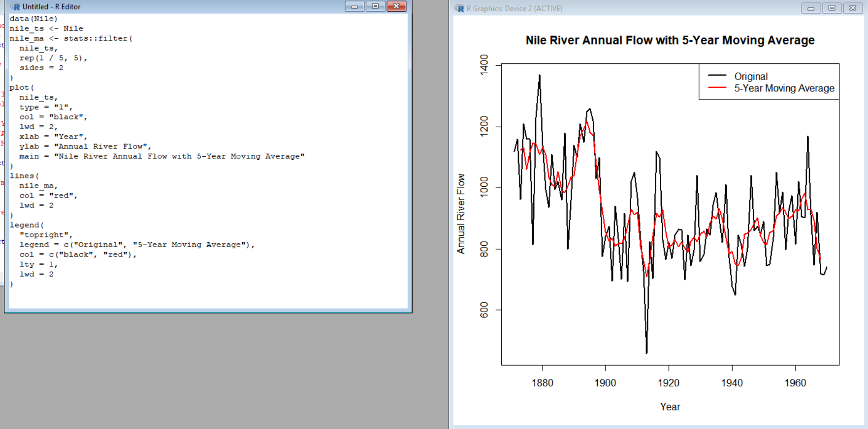

Observation:
The Nile series shows considerable year-to-year variation, while the 5-year moving average smooths these short-term fluctuations and makes the longer-term pattern easier to see. A noticeable change in the level of the series occurs around the late 19th to early 20th century, which is consistent with the well-known level shift in the Nile dataset.

Q2. Multiple Time Series & Dose–Response
Q2(a). Multiple Time Series

R code and output:
if (!requireNamespace("ggplot2", quietly = TRUE)) {
install.packages("ggplot2")
}

if (!requireNamespace("tidyr", quietly = TRUE)) {
install.packages("tidyr")
}

if (!requireNamespace("dplyr", quietly = TRUE)) {
install.packages("dplyr")
)
library(ggplot2)
library(tidyr)
library(dplyr)
stocks_long <- stocks %>%
pivot_longer(
cols = c(DAX, SMI, CAC, FTSE),
names_to = "Index",
values_to = "Value"
)
stocks_long <- stocks_long %>%
group_by(Index) %>%
mutate(
Reindexed = (Value / first(Value)) * 100
) %>%
ungroup()
ggplot(
stocks_long,
aes(
x = Time,
y = Reindexed,
color = Index
)
) +
geom_line(linewidth = 1) +
labs(
title = "Re-indexed European Stock Market Indices",
x = "Time",
y = "Index Value (First Observation = 100)",
color = "Index"
) +
theme_minimal()

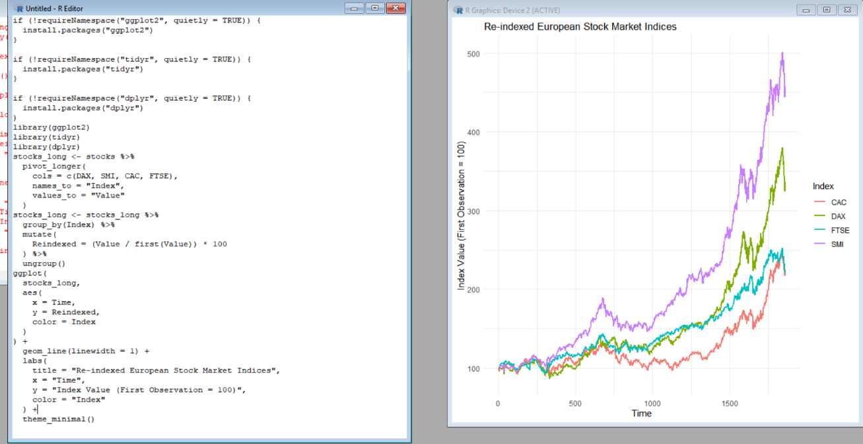

Q2(b). Dose–Response Curve

library(ggplot2)

dose <- read.csv(file.choose())

ggplot(dose, aes(x = concentration, y = root_length)) +
geom_point(size = 3) +
geom_smooth(
method = "loess",
se = FALSE,
linewidth = 1.2
) +
labs(
title = "Ryegrass Dose-Response Curve",
x = "Herbicide Concentration",
y = "Root Length"
) +
theme_minimal()

Interpretation:
The dose–response relationship is expected to show decreasing root length as herbicide concentration increases. The concentration corresponding to approximately 50% of the control root length represents the approximate concentration producing a 50% reduction. The actual numerical concentration must be obtained from the supplied ryegrass_doseresponse.csv, because that file is not included with the document I received.

Q3. Seasonal Decomposition Using STL:

# Q3: STL Decomposition

# Load dataset
air <- read.csv("AirPassengers.csv")

# Convert passengers to monthly time series
air_ts <- ts(
air$passengers,
start = c(1949, 1),
frequency = 12
)

# STL decomposition
air_stl <- stl(
air_ts,
s.window = "periodic"
)

# Plot decomposition
plot(air_stl)

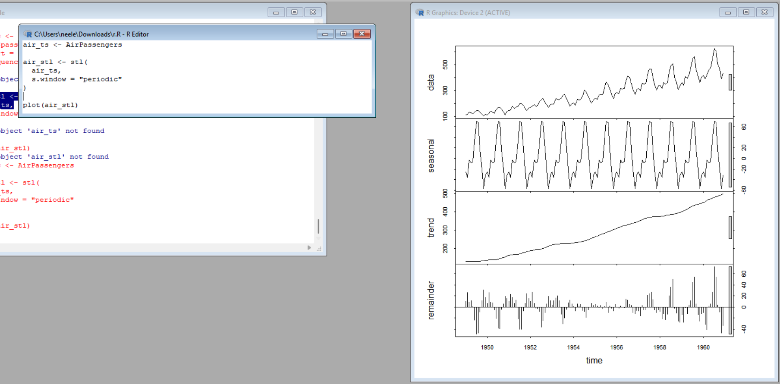

Observation:
A multiplicative decomposition is more appropriate for the AirPassengers series. The seasonal fluctuations become larger as the overall number of passengers increases, meaning the seasonal amplitude depends on the level of the series. This indicates that the variation is proportional to the trend rather than remaining approximately constant.

Q4. Detrending and Residual Analysis

library(ggplot2)

co2_data <- data.frame(
co2 = as.numeric(co2),
time = seq_along(co2)
)

trend_model <- lm(co2 ~ time, data = co2_data)

co2_data$fitted <- fitted(trend_model)

co2_data$detrended <- co2_data$co2 - co2_data$fitted

ggplot(co2_data, aes(x = time, y = co2)) +
geom_line() +
geom_line(aes(y = fitted), linewidth = 1) +
labs(
title = "Mauna Loa CO2 with Linear Trend",
x = "Time",
y = "CO2"
) +
theme_minimal()

ggplot(co2_data, aes(x = time, y = detrended)) +
geom_line() +
geom_hline(yintercept = 0, linetype = "dashed") +
labs(
title = "Detrended CO2 Series",
x = "Time",
y = "Detrended CO2"
) +
theme_minimal()
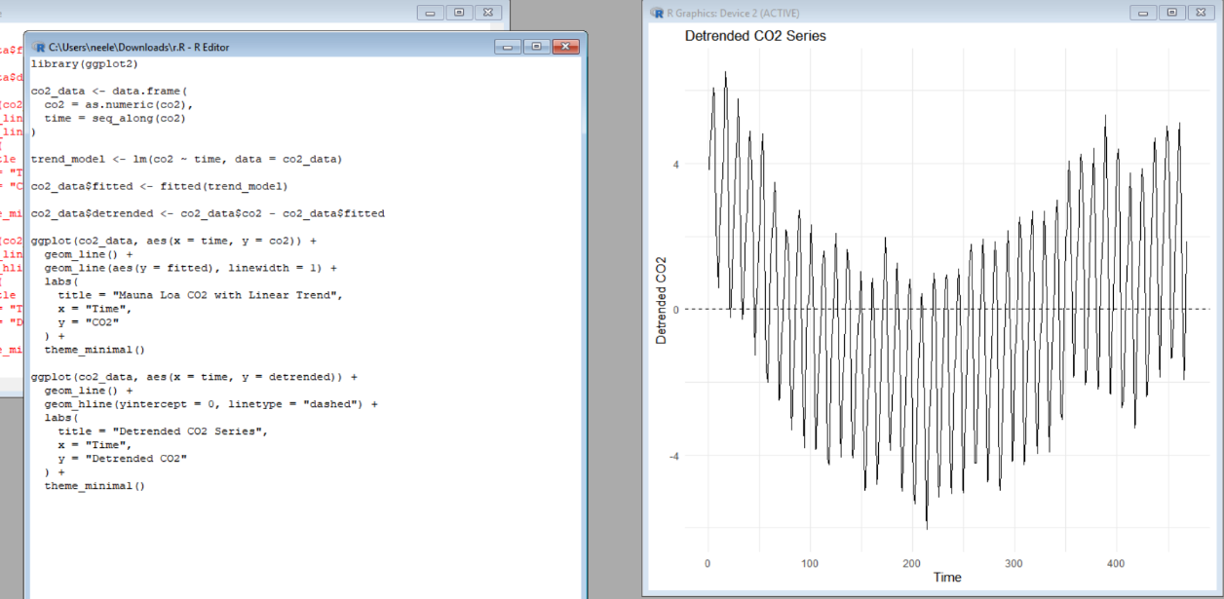

observation:
The original CO₂ series has a strong long-term upward trend together with clear repeating annual fluctuations. After removing the linear trend, the long-term increase is reduced, but a strong seasonal pattern remains in the residual series. Therefore, simple linear detrending is not sufficient to remove all systematic structure because it removes the trend but does not account for the strong annual seasonality.

Q5. Forecasting and Cycle Detection

R code and output:

if (!requireNamespace("forecast", quietly = TRUE)) {
install.packages("forecast")
}

library(forecast)

air_ts <- AirPassengers

fit <- ets(air_ts)

fc <- forecast(
fit,
h = 24
)

autoplot(fc) +
labs(
title = "24-Month Forecast of AirPassengers",
x = "Year",
y = "Passengers"
) +
theme_minimal()

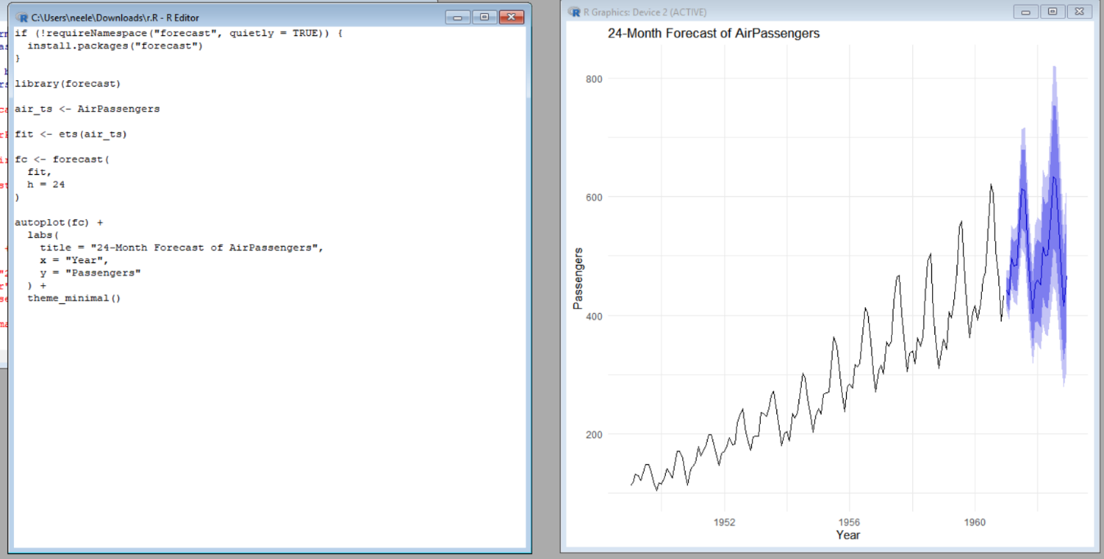

Observation:
The forecast should continue the historical upward trend while retaining a repeating seasonal pattern. The seasonal peaks and troughs in the forecast are consistent with the strong monthly seasonality observed in the historical AirPassengers data. The prediction intervals widen as the forecast horizon increases, reflecting increasing uncertainty.

